SCALEO® Li 2630  You can count on me | Issue |  | October 2007
SCALEO® Li 2630  You can count on me | Pages |  | 3
The SCALEO Li 2630 is a compact all-round PC for the whole family. No matter if you want to surf the Internet, edit your holiday pictures or listen to music the SCALEO Li 2630 is perfectly equipped for your daily computing needs. Chat with friends via Internet and invite them to your home to watch your favorite DVD or your latest videos. Or invite them to a party - with the SCALEO Li 2630 your personal juke box is always available. And thanks to FireWire™ and USB best connectivity is assured.
With the SCALEO Li 2630 you get a powerful PC with lots of connectivity and a stylish design at a favorable price.

- Intel® Pentium® Dual Core™ processor E2140

- Graphic power thanks to ATI Radeon™ HD 2350 SE with 64 MB Video RAM and up to 256 MB HyperMemory™ (VGA and DVI-I interface)

- Up to 4 GB RAM for fast working conditions

- Super Multi DVD writer with dual layer support, to write your important pictures, songs and documents on CD or DVD

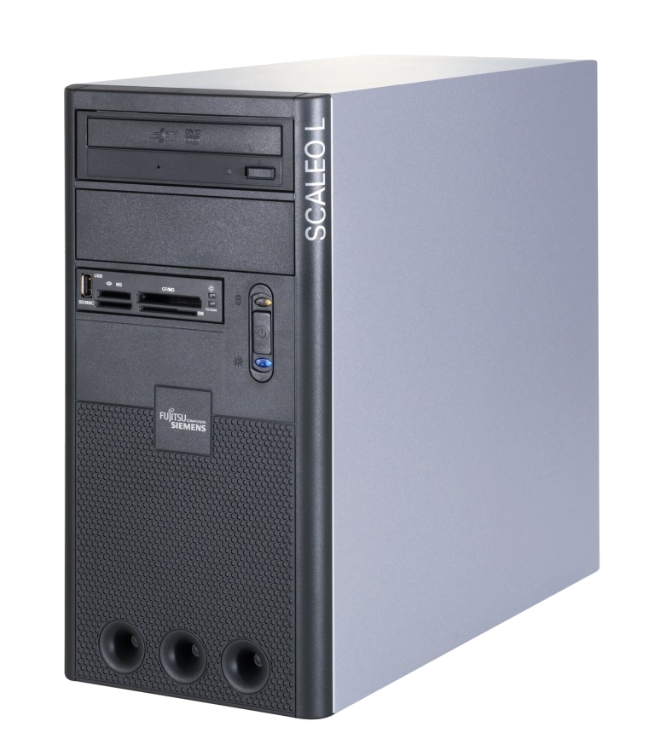
- Up to 500 GB storage capacity for all your videos, pictures, music and more

- 11-in-1 card reader and USB port on the front for easy accessibility

- Easy connectivity through LAN (GbE) and WLAN (optional)

- Ideal for daily computing tasks and home office

- Best price/performance ratio

Operating Systems
(preinstalled and on recovery CD)
Fujitsu Siemens Computers recommends
Windows Vista® Home Premium
Microsoft® Windows Vista® Home Premium,
Microsoft® Windows Vista® Home Basic or
Linux (DVD only)
Housing SCALEO L
Physical Features
Size µ ATX
Dimensions 370 x 185 x 410 mm
(H x W x D)
Weight 11 kg fully assembled /
with ODD + CR
Ambient Temperature 15°C – 35°C
(IEC 721)
Standard Features
(actual configuration may vary)
Power Supply
Size ATX
Voltage 220 – 240 V
Frequency 50 – 60 Hz
Max. Output 350 W
Security Functions
Password Protection Setup and Boot
Certificates and Compliance
Product Safety IEC60950-1, EN60950-1,
LVD 2006/95/EC
Electromagnetical EN55022/B, EN55024,
EN61000-3-2/3,
EMC 2004/108/EC
Environmental FSC-03230
RoHS
Hardware WHQL, Windows Catalog,
IEEE1394 (FireWire™),
USB 2.0
Designed for
Microsoft® Windows Vista®
Drivers and Utility
Included on DVD or on hard disk
Updates downloadable at
http://www.fujitsu-siemens.com
System, processor, architecture
Mainboard Chipset:
Intel® G31 Express Chipset
CPU
Intel® Pentium® Dual Core™ E2140
(1.6 GHz, 800 MHz, 1 MB L2 cache)
VGA
ATI Radeon™ HD 2350 SE with 64 MB Video RAM and up to 256 MB HyperMemory™ with DVI-I, VGA and TV-out interfaces
(Benchmark: 3D Mark 2006: up to 1000 points)
Memory
2 DDR2 SD-RAM slots
dual or single channel through Intel® flex memory technology
up to 4 GB with 512, 1024 or 2048 MB modules
(DDR2 667)
Drives
HDD (SATA2, 1x 3.5” bay internal)
160, 250, 360 or 500 GB SATA2 / 7200 rpm
ODD (2x 5.25” bays)
1x multi-format DVD writer and Double Layer support
(CD, CD-R, CD-RW, DVD, DVD+R-R, DVD+R/RW-R/RW
Double Layer DVD+R)
1x multi-format DVD reader (optional)
Other (1x 3.25” bay)
1x 11-in-1 card reader and 1x USB 2.0
Audio
7.1 high-definition audio
Connectivity
LAN 10/100/1000 MBit (GbE)
Accessibility Options
Front
1x USB 2.0
1x 11-in-1 card reader
Rear
4x USB 2.0, 1x IEEE1394, 1x LAN (GbE)
6x HD Audio 7.1
1x DVI-I, 1x TV out
2x VGA (one disabled, if external graphics plugged in)
Internal
1x PCI Express 16x
1x PCI Express 1x
2x PCI
4x SATA
Application Software¹
(preinstalled and with recovery option)
- Microsoft® Works
- Microsoft® Office Home and Student Trial
- Adobe Acrobat Reader
- Nero Essentials S (CD/DVD burn software)
- Norman Virus Control or
Symantec Norton Internet Security (security software)
- Country specific Internet Service Providers
- other software depends on country
Accessories (optional)
- Wireless keyboard USB slim with laser mouse,
Multimedia keyboard USB
Standard keyboard USB
- Optical wheel mouse USB
Ball wheel mouse USB
All rights reserved, including intellectual property rights. Technical data subject to modifications and delivery subject to availability. Any liability that the data and illustrations are complete, actual or correct is excluded.  Designations may be trademarks and/or copyrights of the respective manufacturer, the use of which by third parties for their own purposes may infringe the rights of such owner.  For further information see http://www.fujitsu-siemens.com/terms_of_use.html  Copyright © Fujitsu Siemens Computers 10/2007 |  | Published by  Fujitsu Siemens Computers  http://www.fujitsu-siemens.com/ | Company stamp

- Some applications may not be available in all countries.
The configuration described in this document is an example only and non-binding. For the exact configuration of your SCALEO, please contact your licensed dealer.

